A

PROJECT REPORT

ON

**Online City Information**

**By**

**Machchhar Palna (CE-68)**

**Mahyavanshi Jenil (CE-69)**

**Shah Diya (CE-138)**

**B.Tech CE Semester-V**

**Subject: Advanced Technology**

**Guided by:**

Prof.Prashant M. Jadav

Prof.Siddharth P. Shah



**Faculty of Technology**

**Department of Computer Engineering**

**Dharmsinh Desai University**



**Faculty of Technology**

**Department of Computer Engineering**

**Dharmsinh Desai University**

**CERTIFICATE**

This is to certify that the practical / term work carried out in the subject of **Advanced Technology** and recorded in this journal is the bonafide work of

**Machchhar Palna (CE-68)**

**Mahyavanshi Jenil (CE-69)**

**Shah Diya (CE-138)**

of B.Tech semester **V** in the branch of **Computer Engineering**

during the academic year **2020-2021**.

**Contents:**

1. Abstract ................................................................................................... 4
2. Introduction ............................................................................................. 5
3. Software Requirement Specifications .................................................... 7
4. Design
   1. Use Case diagram ............................................................ 11
   2. Sequence diagram ............................................................ 12

III)Activity diagram ............................................................ 14

IV) Class diagram ............................................................... 16

V) Data Flow diagram ............................................................17

1. Implementation Detail
   1. Modules ...................................................................................... 20
   2. Major Functionality ................................................................... 22
2. Work Flow / Layouts ........................................................................ 23
3. Conclusion ........................................................................................ 28
4. Limitation and Future extension ........................................................ 29
5. Bibliography ......................................................................................... 30

# 1. Abstract

City Information System Provides a simple interface to see the details of a particular city. This can be used by travel agents, students or any particular user who is interested to search about city. The main purpose of this project is to help [tourists](https://www.codewithc.com/online-tourism-management-system-vb-net-project/) and other visitors of an unknown city by providing information about famous places and food. This Project serves the visitors as a reliable and user-friendly guide of the city. It also contains map which shows exact location of famous places of a city.

# 2. Introduction

## **2.1 Brief Introduction**

Whenever a person visiting a new city wants to get some information about the city, then they need to ask the locals or take help from the guide in the city. This requires lots of time and the person might need to ask multiple times. The design and implementation of City Information System and user interface is to replace this tedious job. The system utilizes user and admin authentication.

Admin can add the cities along with location and brief details about that city. Also he can add famous places and food details for particular city along with image and location. Admin can also update or delete details of city, place and food. User can see the all the cities name by logging in to the system. He/She can view his/her desirable city details by clicking on that particular city. User can also see exact location of all famous places by clicking on the map.

## **2.2 Tools/Technologies Used**

**Technologies:**

* React Library
* Express
* NodeJS
* MongoDB
* Bootstrap
* JavaScript
* jQuery
* HTML
* CSS

### **Tools**

* GitHub
* Visual Studio Code

**Platform**

* Local Host

# 3. Software Requirement Specifications

**Admin**

**R.1 Login**

Description: Admin can login by entering email and password.

Input: Enter email and password

Output: Show Admin Panel.

**R.2 Add City**

Description: Admin can add new city by entering city details like image, location etc.

Input: Details of city

Output: “confirmation message” (City added Successfully)

**R.3 Add Place**

Description: Admin can add new place by entering place details like image, location etc. and also select appropriate city.

Input: Details of place

Output: “confirmation message” (Place added Successfully)

**R.4 Add Food**

Description: Admin can add famous food by entering food details like image, location etc.

Input: Details of food

Output: “confirmation message” (Food added Successfully)

**R.2 Update City Details**

Description: Admin can update all city details.

Input: change value of input field.

Output: “confirmation message” (City detail updated Successfully)

**R.2 Update Place Details**

Description: Admin can update all place details along with changing its city.

Input: change value of input field.

Output: “confirmation message” (Place detail updated Successfully)

**R.2 Update Food Details**

Description: Admin can update all Food details like location, image etc .

Input: change value of input field

Output: “confirmation message” (Food detail updated Successfully)

**R.2 Delete City**

Description: Admin can Delete particular city

Input: By clicking delete button.

Output: “confirmation message” (City deleted Successfully)

**R.2 Delete Place**

Description: Admin can Delete particular place.

Input: By clicking delete button.

Output: “confirmation message” (Place deleted Successfully)

**R.2 Delete Food**

Description: Admin can Delete particular food

Input: By clicking delete button.

Output: “confirmation message” (Food deleted Successfully)

**User**

**R.1 Register**

Description: Users can register by giving their details.

Input: User details

Output: Shows Login Page

**R.1 Login**

Description: User can login by entering email and password.

Input: Enter Email and password

Output: Shows User Panel.

**R.2 View City**

Description: User can view city details by clicking button. It will display all places and food along with their locations on the map.

Input: Click on View button.

Output: Shows all the locations on the map.

**R.3 Logout**

Description: User can logout by clicking on the logout button.

Input: click logout button.

Output: Shows Login Panel.

# 4. Design

**4.1** **Use Case Diagram**

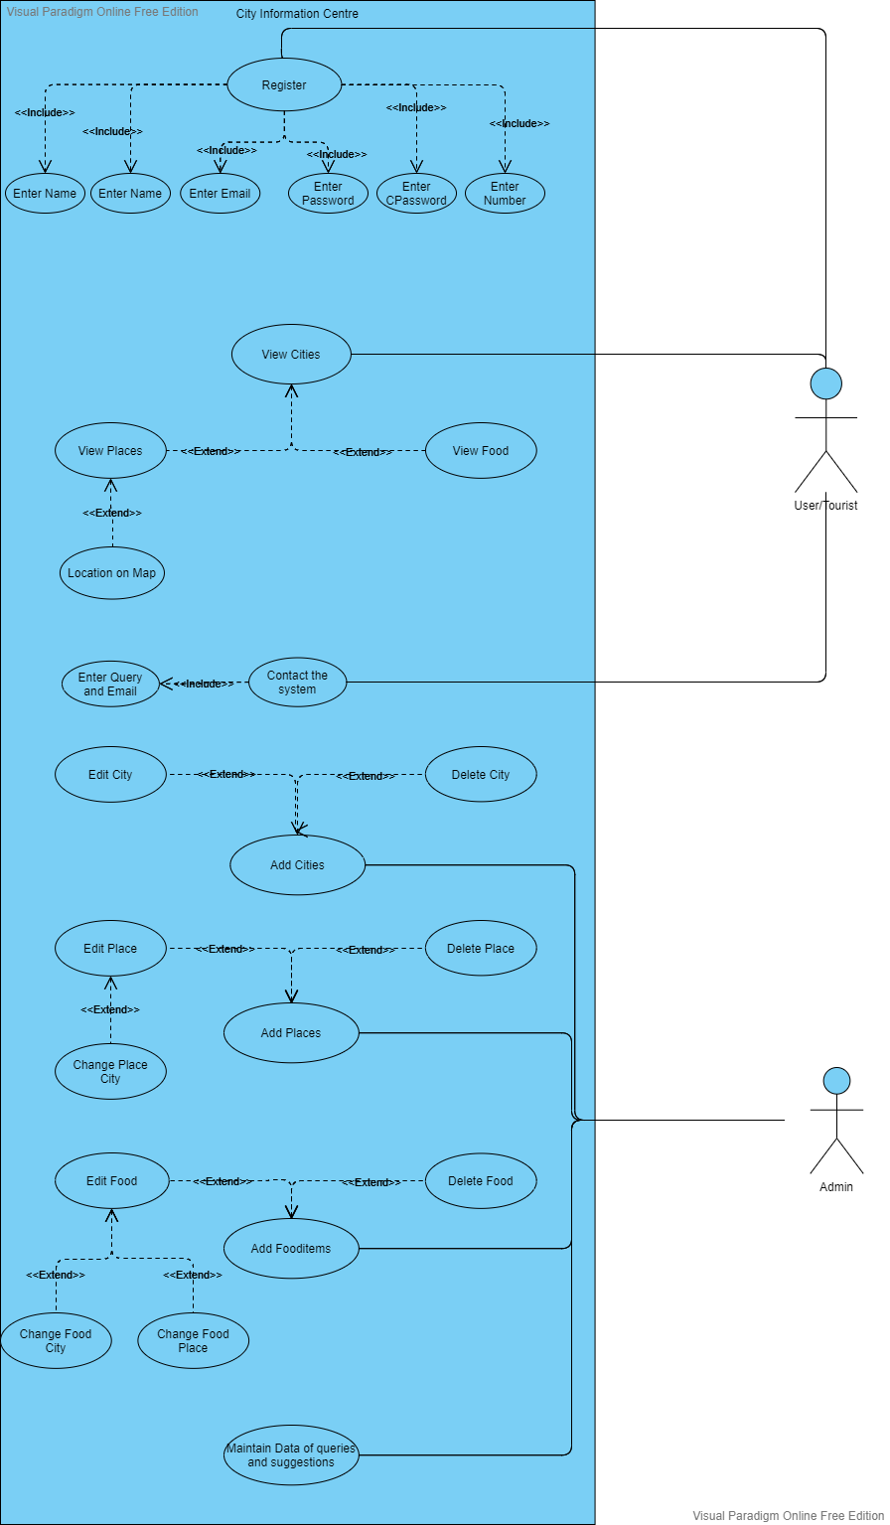

**4.2 Class Diagram**

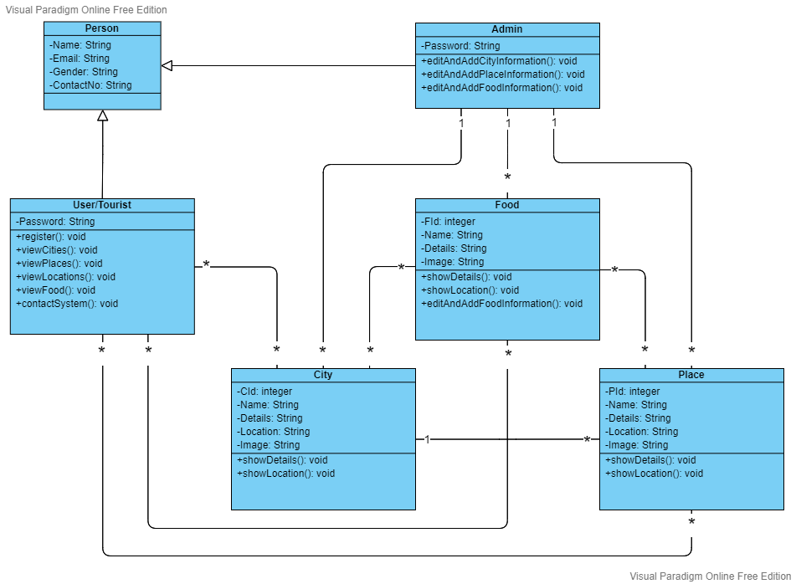

**4.3 Data Flow Diagram**

**Level 0:**

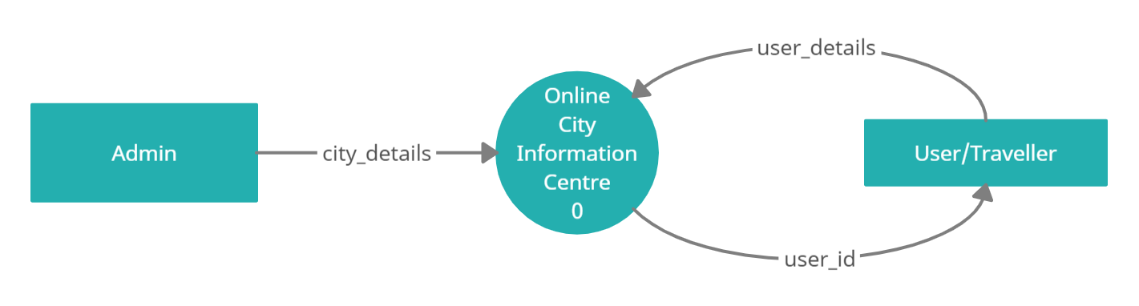

**Level 1:**

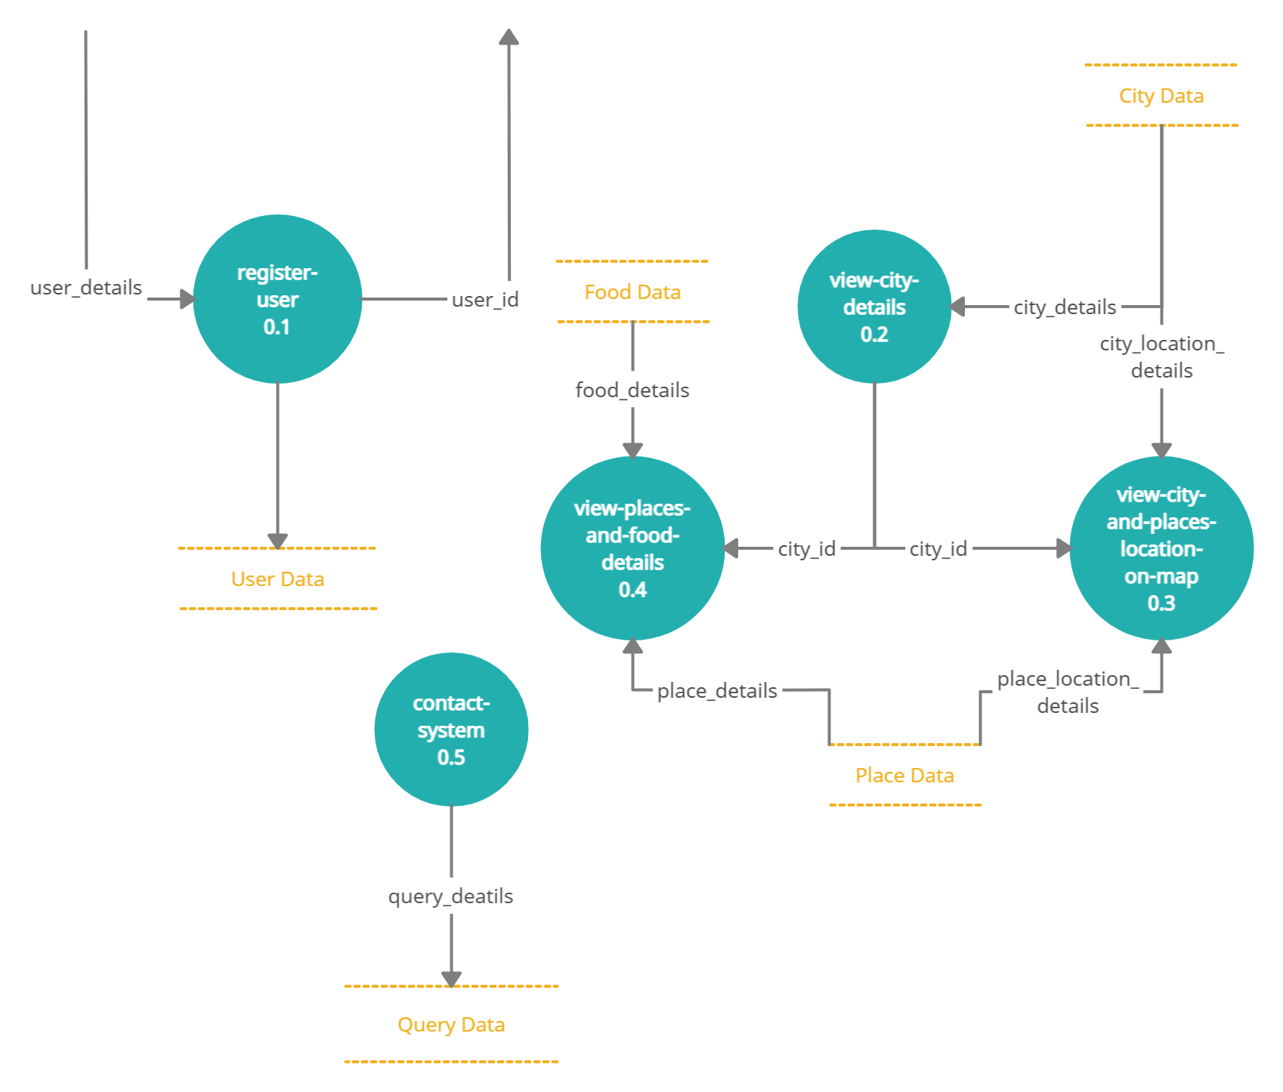

**4.4 E-R Diagram**

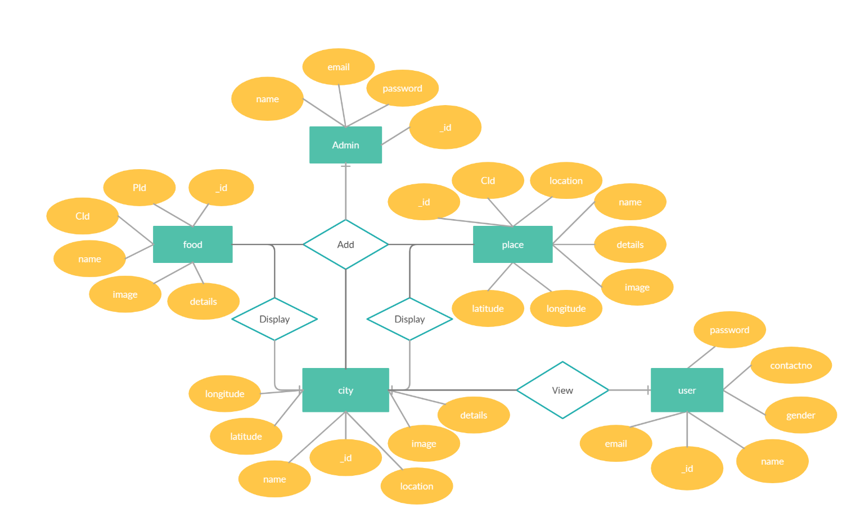

* 1. **Data Dictionary**

1. **User Schema**

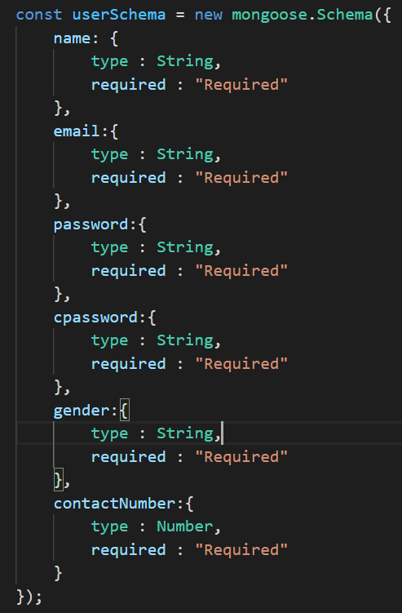

1. **City Schema**

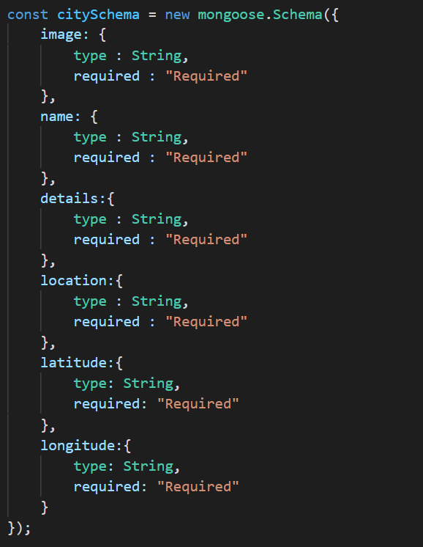

1. **Place Schema**

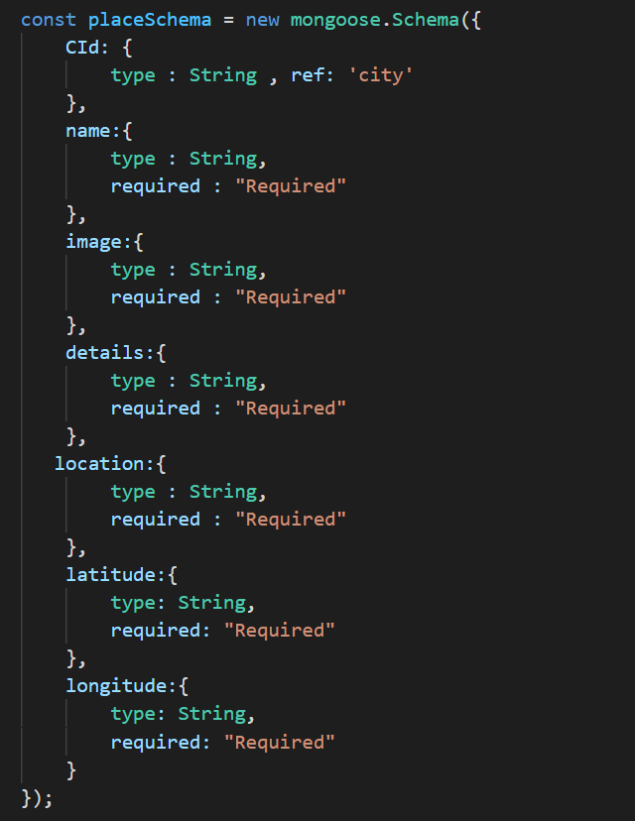

1. **Food Schema**

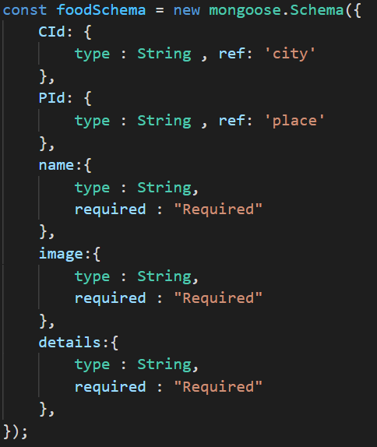

# 5. Implementation Details

The system consists of 2 basic modules namely

1. User Module
2. Admin Module

Each module consists of several methods to implement the required functionality. Implementation is done using Express and NodeJs. Database used in these modules is MongoDB.

1. **User Module**

* This module is the base for user authentication to ensure the security aspect. It includes user login and registration details.
* It also displays all cities names along with their famous places and food.

1. **Admin Module**

* This module firstly authenticates admin credentials and then admin can see all the details of cities, places and food.
* In this module admin can add new city, place and food and also update or delete all the details of existing city, place or food whenever required.

### **5.2 Function prototypes**

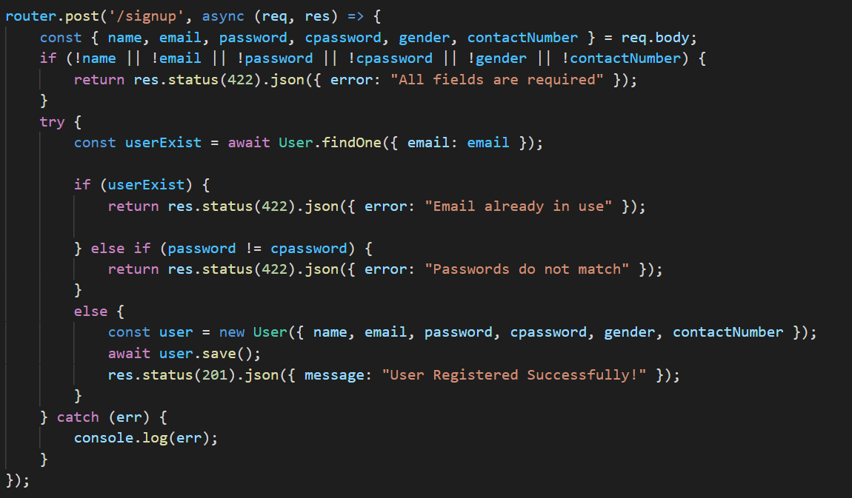

**User Signup**

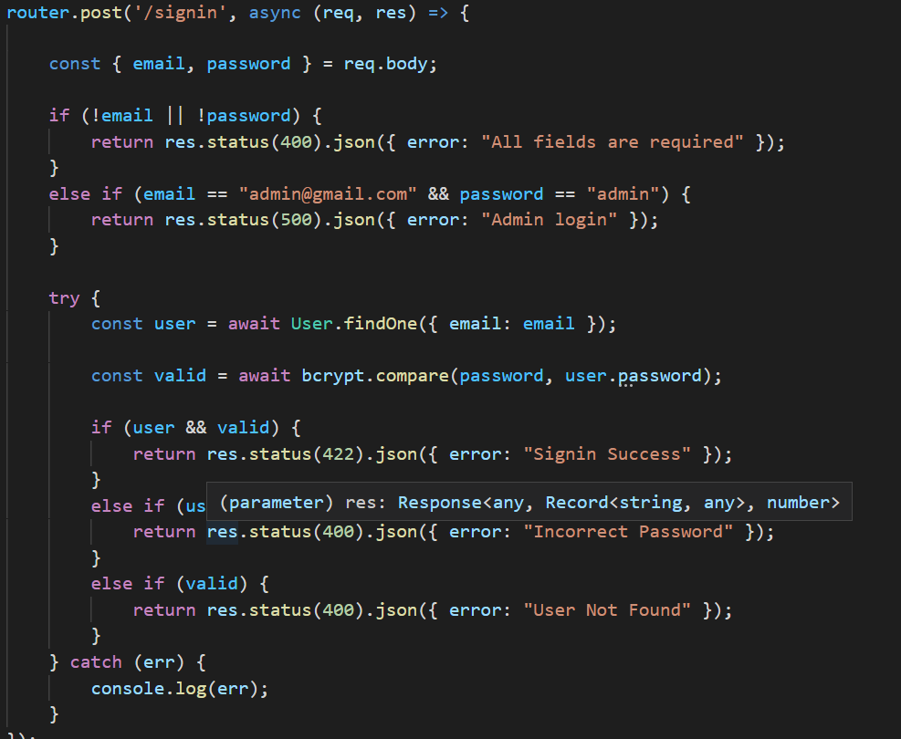

**Authentication module for admin and user**

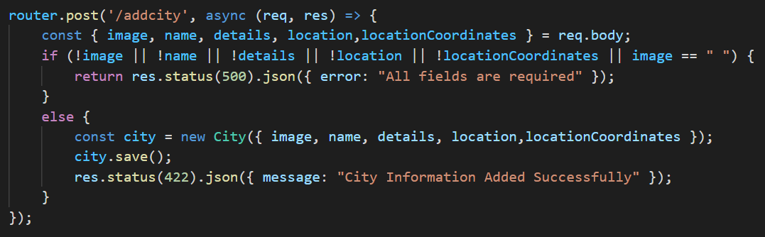

**Admin module for add city**

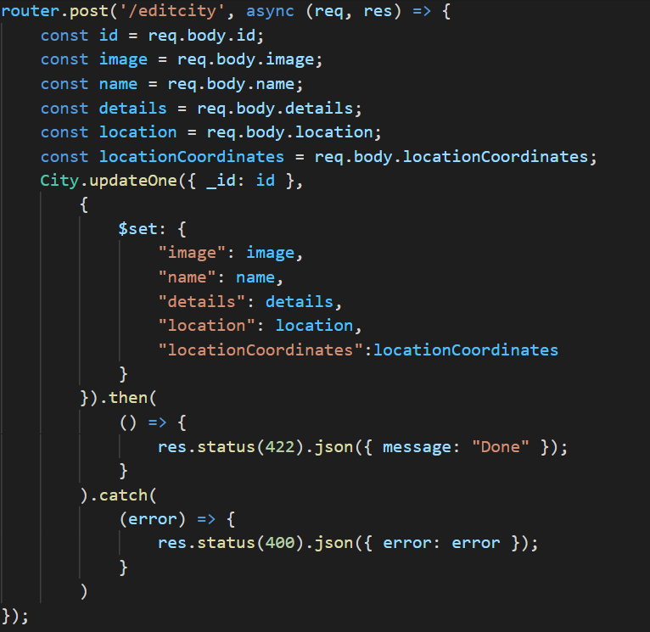

**Admin module for update city**

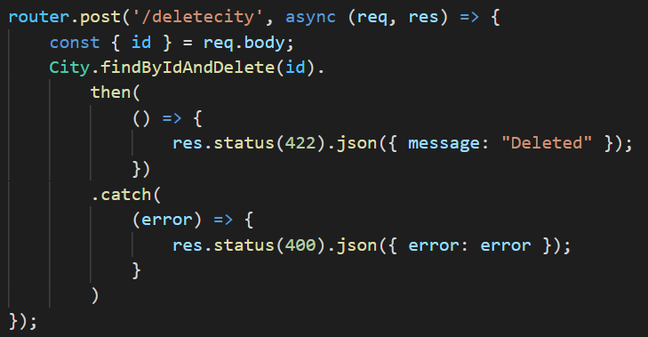

**Admin module for Delete city**

# 6. Screenshots



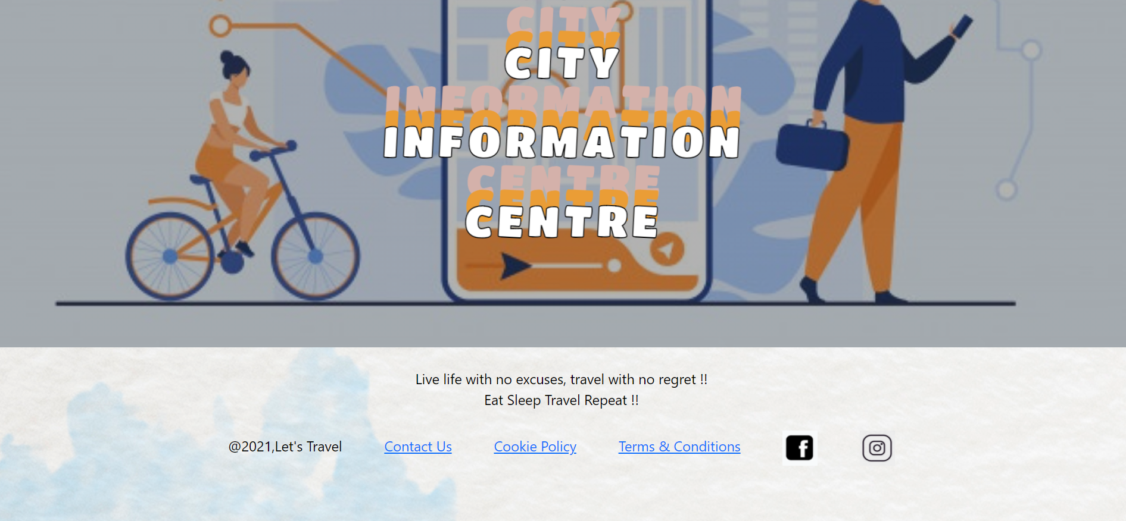

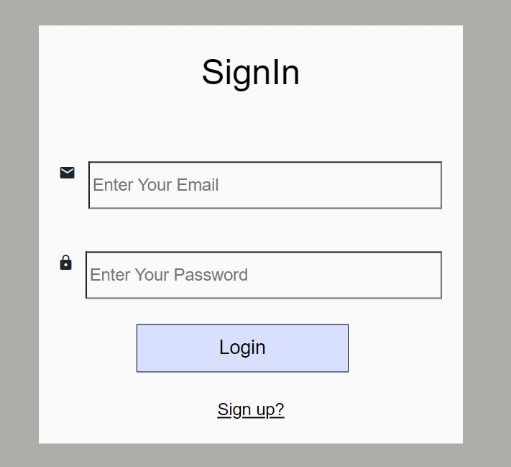 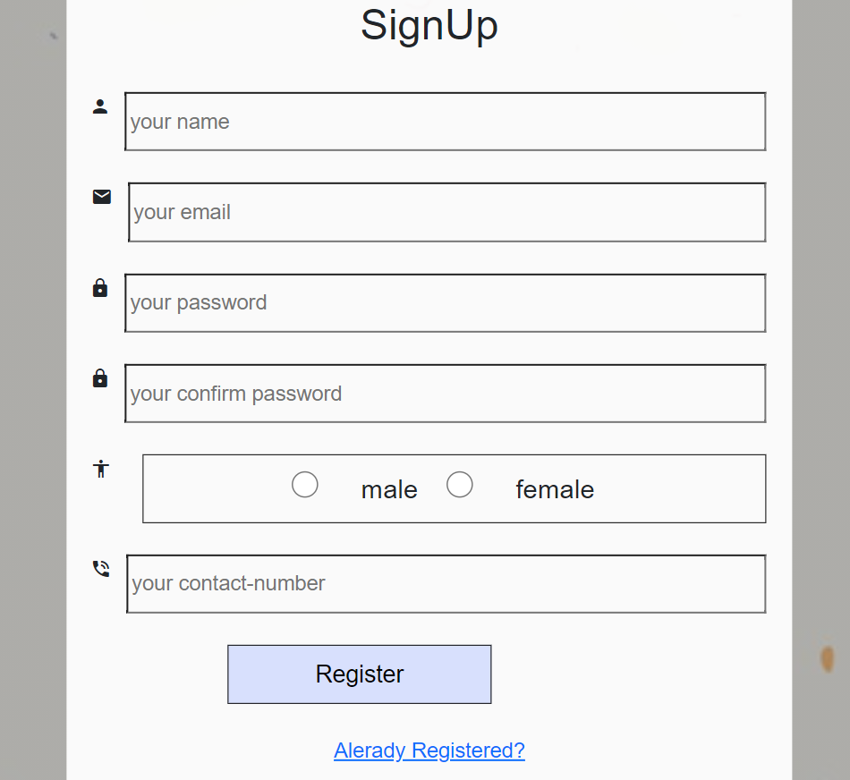

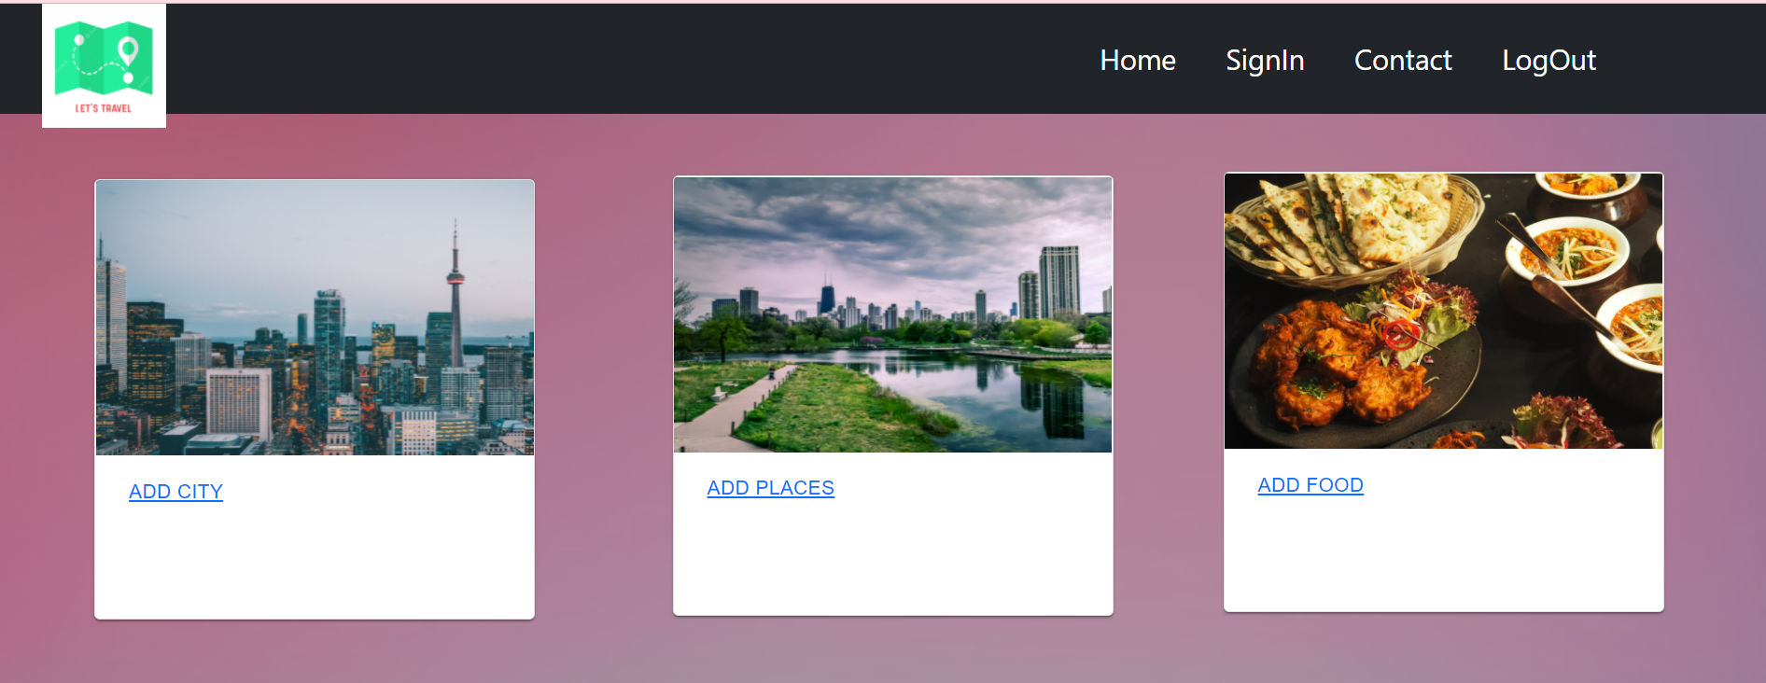

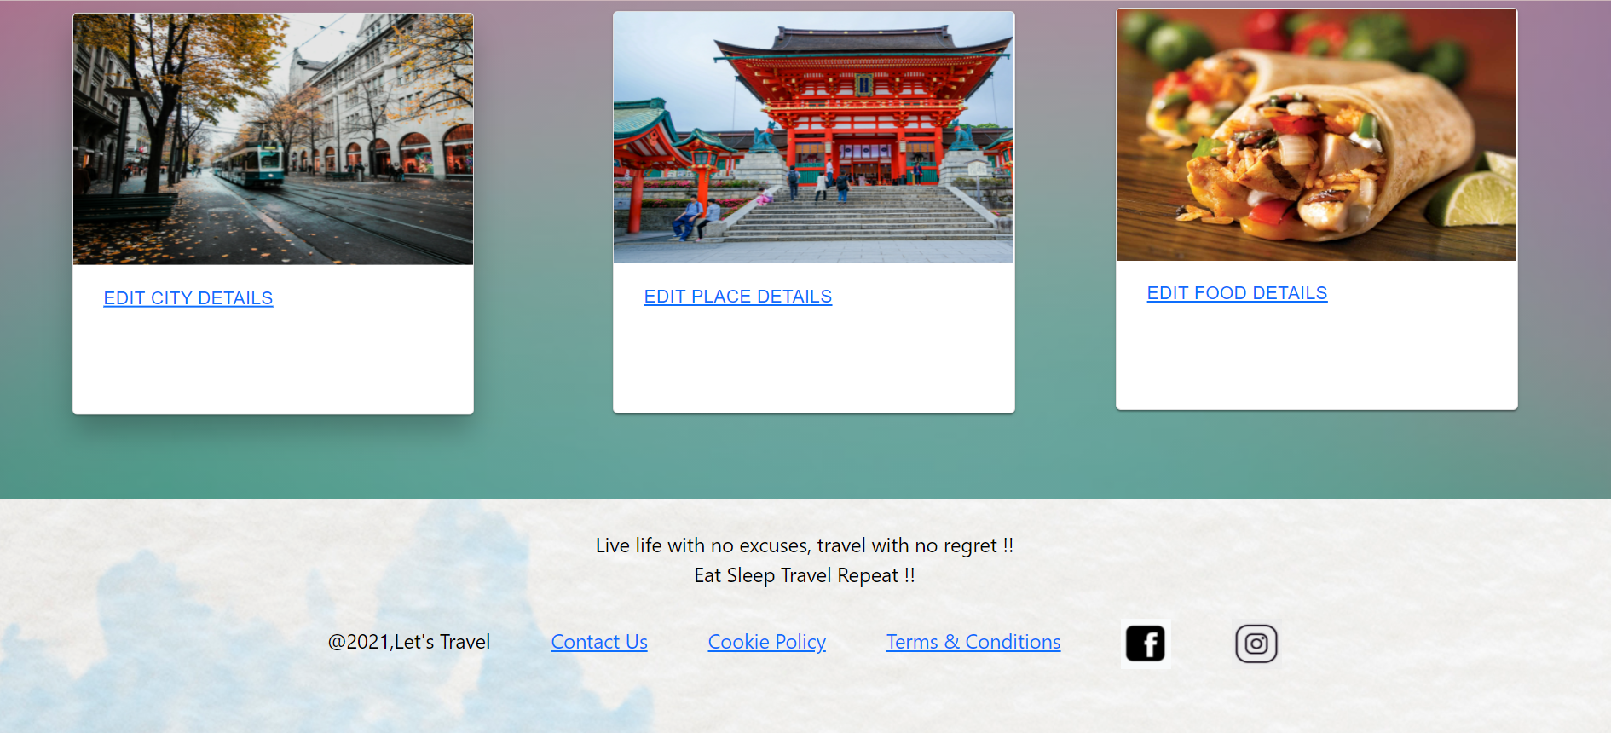

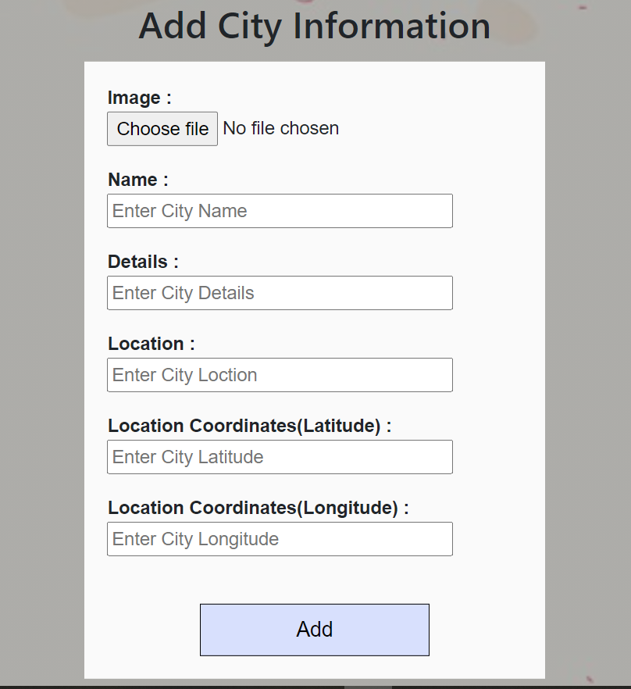

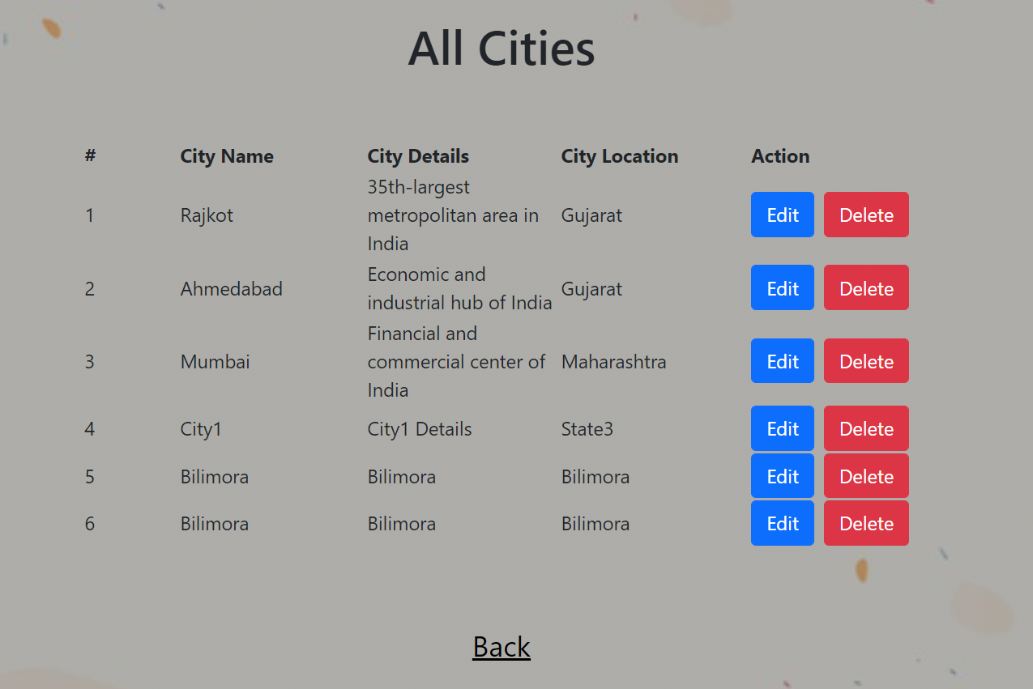

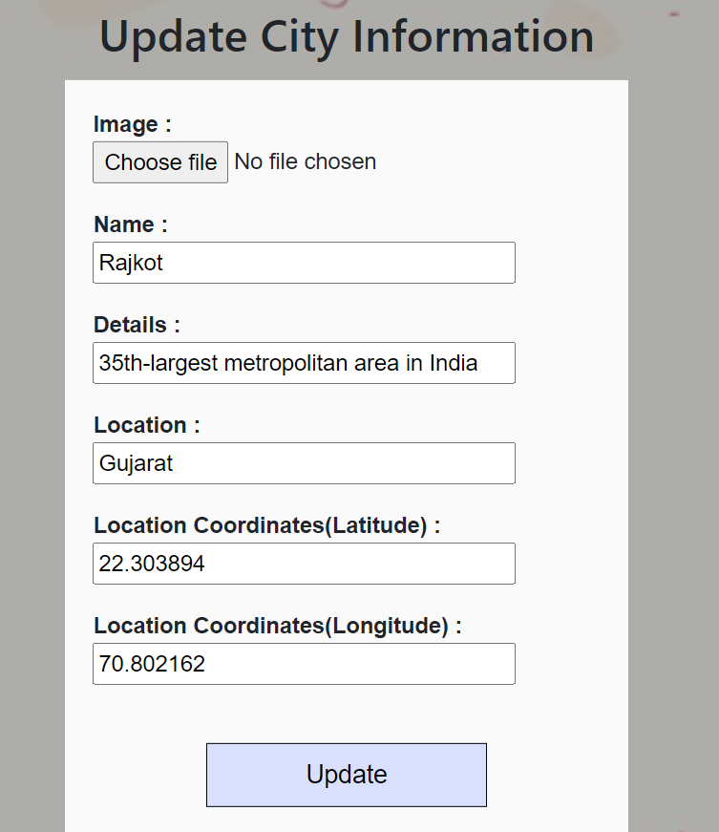

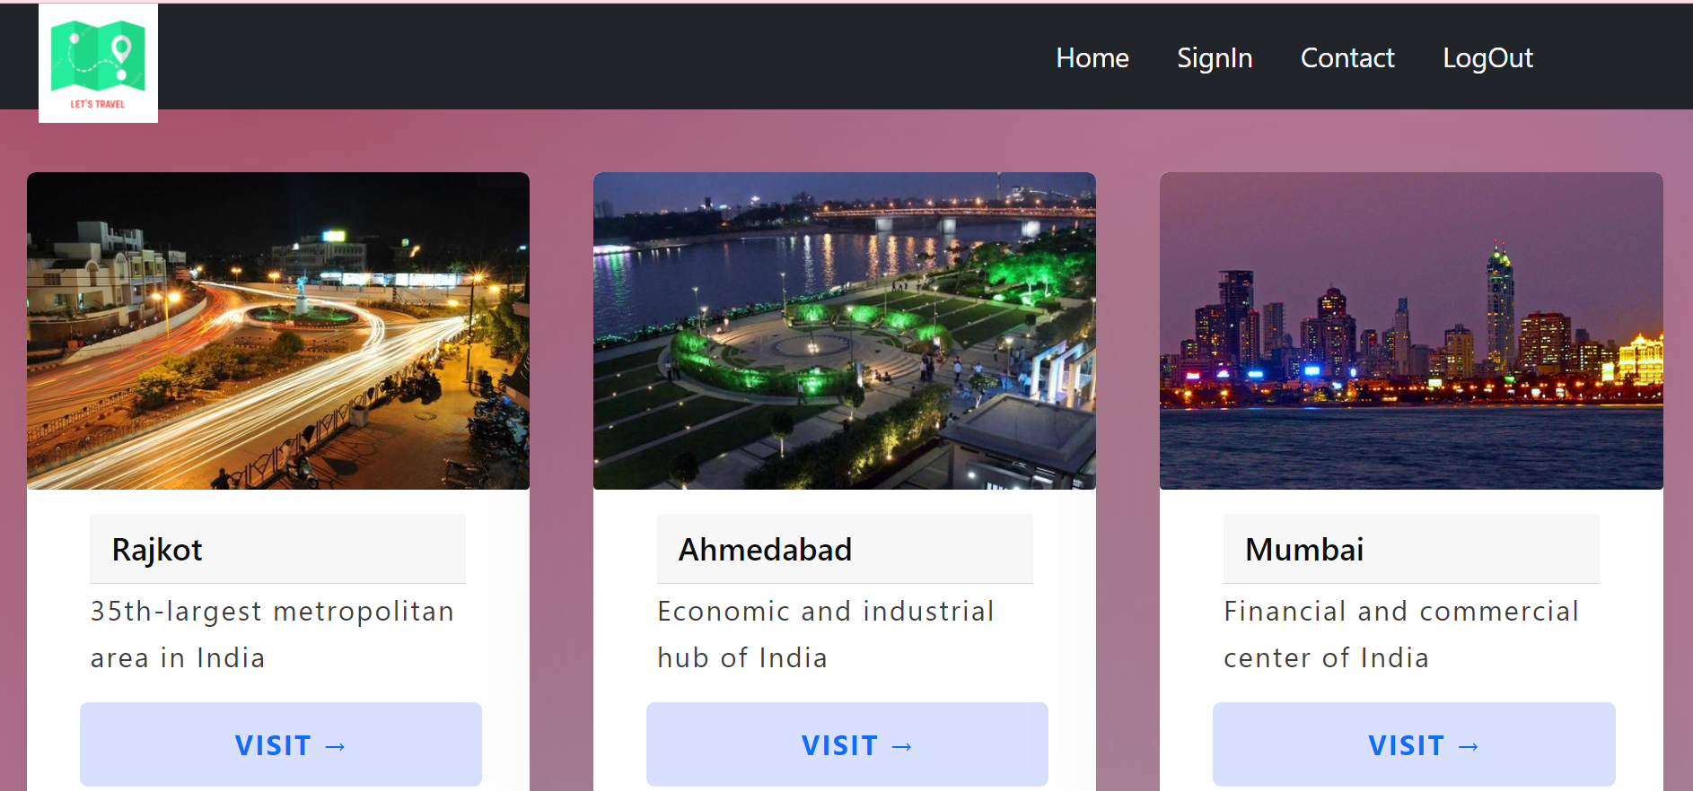

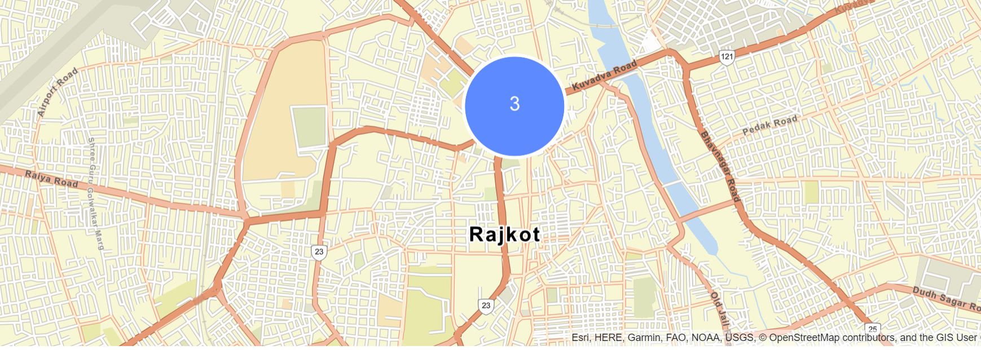

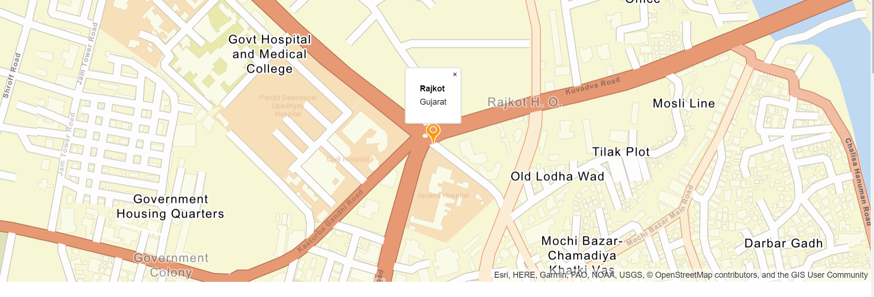

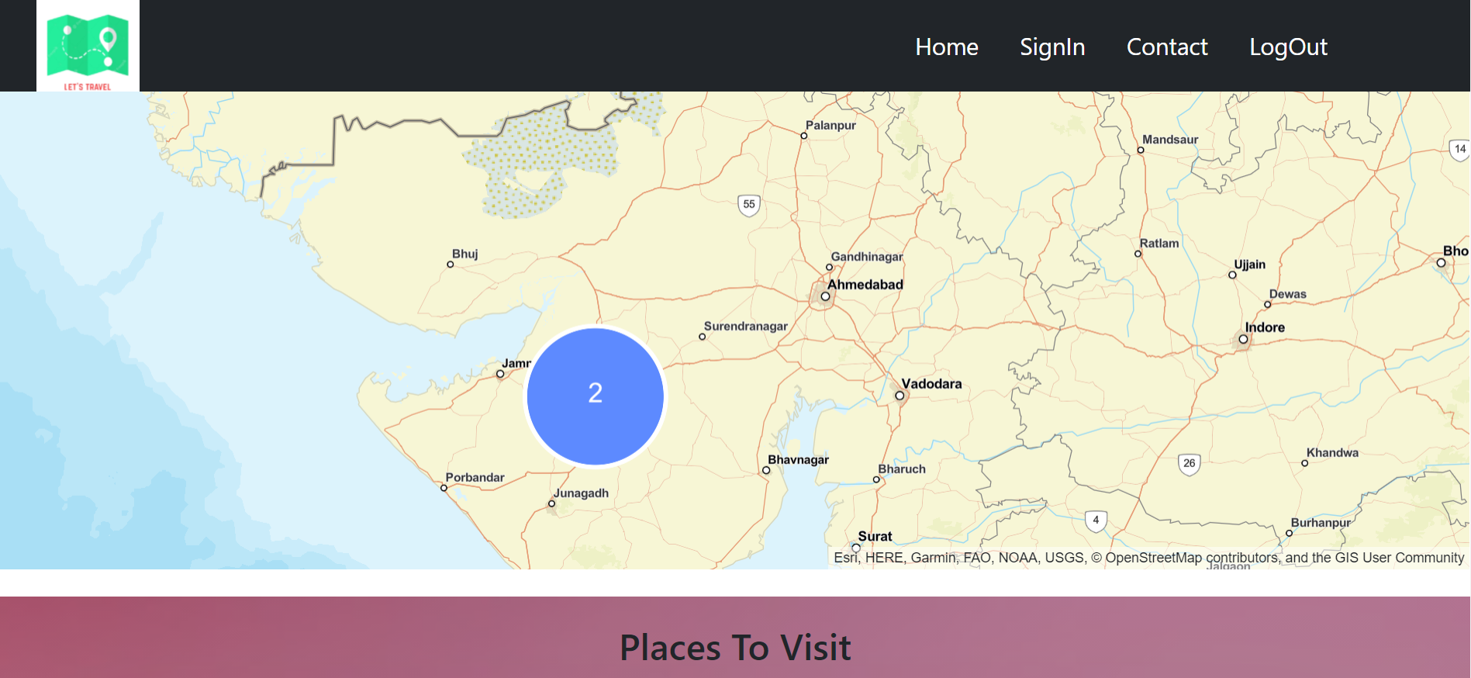

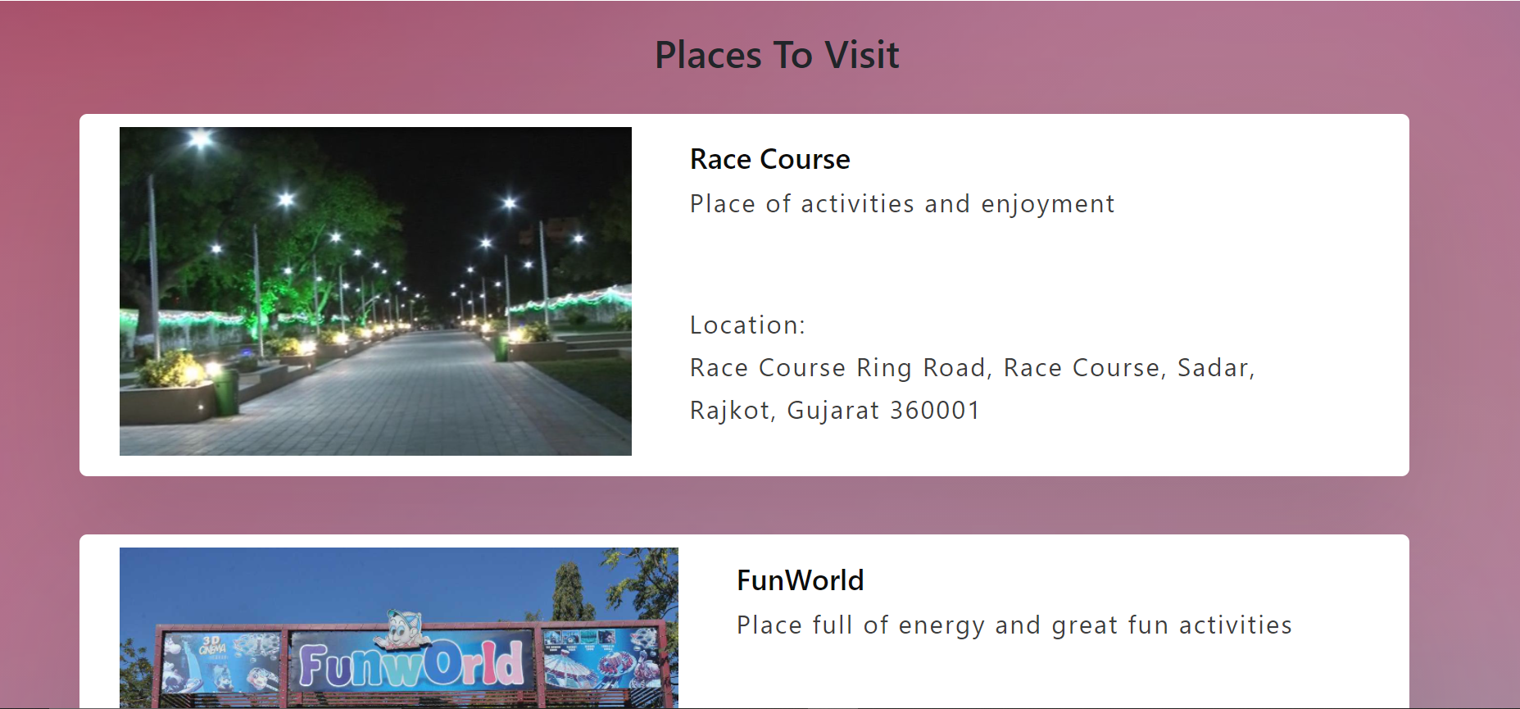

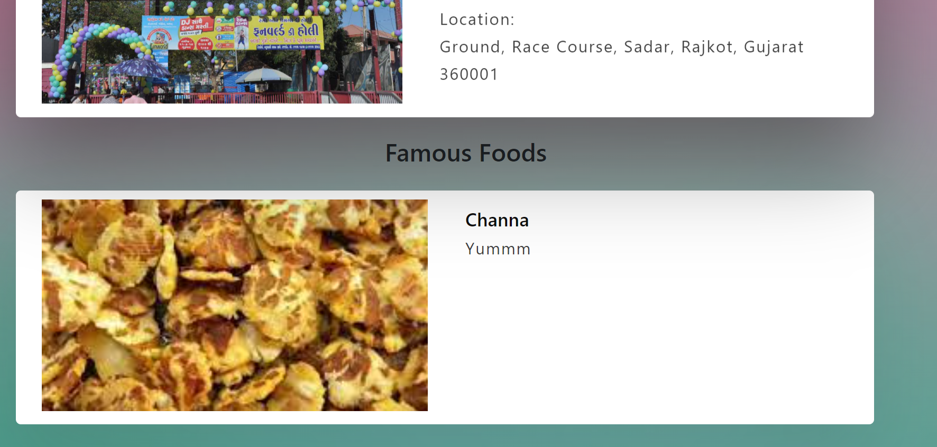

# 7. Testing

Manual testing was performed in order to find and fix the bugs in development process.

**Testing Method**: Manual Testing

|  |  |  |  |  |
| --- | --- | --- | --- | --- |
| **Sr.**  **No.** | **Test Scenario** | **Expected Result** | **Actual Result** | **Status** |
| 1 | Login with incorrect credentials | User should not able to log in. | User is given a message. And redirected to login page. | Success |
| 2 | Login with correct credentials | User should be able to log in. | User is logged in and redirected to home page. | Success |
| 3 | Validations on registration | User should not be allowed to enter incorrect email, password, re-enter password. | User is shown a message for any incorrect input data. | Success |
| 4 | Registering with an existing username. | The system should show a message. | The system shows the message ‘User already registered.’ | Success |
| 5 | Add city without filling details | Admin should not able to add city in database. | The system shows the message ‘Invalid data/input’. | Success |

|  |  |  |  |  |
| --- | --- | --- | --- | --- |
| 6 | Add Place without filling details | Admin should not able to add place in database. | The system shows the message ‘Invalid data/input’. | Success |
| 7 | Add Food without filling details | Admin should not able to add food in database. | The system shows the message ‘Invalid data/input’ . | Success |
| 8 | Remove any city, place, food | Admin should be able to remove the details from the database. | Message will be shown as ‘Successfully Deleted’ | Success |
| 9 | Log Out | User should be logged out | User is successfully logged out and not able to see the city details. | Success |

# 8. Conclusion

Hence-forth in this project we have successfully implemented the Admin-side & User-side functionality.

Admin can add city, place and food details. Also admin can edit and delete city, place and food details.

The user can view details of the city and its places and food as per their choice. They can even check the locations of the city and its places on map.

# 9. Limitations and Future Enhancements

Limitations:

1.) There is no provision for user to change his/her email or password.

2.) Email id entered by user cannot be verified.

Future Enhancements:

1.) We can add hotels section which will display some if not all hotels of a city.

2.)

# 10. Reference / Bibliography

Stackoverflow: <https://stackoverflow.com/>

React official documentation: <https://reactjs.org/docs/getting-started.html>

W3Schools: [https://www.w3schools.com/](https://www.w3schools.com/%20)

GeekForGeeks: <https://www.geeksforgeeks.org/>